KINGSBAY AREA SERVICE COMMITTEE
2071 Flatbush Avenue, Suite 230, Brooklyn NY 11234 KBAofNA.org
Monthly Report

Meeting Date: MARCH 13, 2023 6:30 PM

Meeting opened @ 6:30 PM - Serenity Prayer, 12 Traditions, 12 Concepts and Service Prayer were read.

ROLL CALL: Trusted servant’s & Group’s roll call taken (included).
REPORTS:

CHAIRPERSON: Teresa is here to speak on Concept 2. We still have open positions that need to be filled; Vice-chair, PI, E & A, and Merchandise. Starting March 26, 2023, we will be having our steering committee meetings the last Sunday of every month at 6:30 at via zoom, ID# 6101322211 password 553764.
VICE-CHAIRPERSON: Open position.

Treasurer: (Report attached) Our current balance is $3,124.70. We now have SPECIALTY key tags in 5, 10, 15, 20, 25, and 30 years at $2.50 each. We also have 10,000 days and Welcome Back key tags. We have the LIMITED Edition 60TH year White Book for $15 each. We also have SPAD Spiritual Principle a Day we are selling for $15 each.
Public Information: Open Position.

H & I: (report attached) We will be meeting with the Harbor View
VA on March 18 to discuss vetting requirements. We need trusted servants to help carry the message (see attached flyer). The Vice Chair position is open for elections.

RCM/RCM ALT: Open Position. There will be elections for 2 open BOD members. The next regional convention is now scheduled for 2025. The GNYRSO is open sporadically so go online to check their hours. Please post all events to go on the regional calendar at calendar@newyork.org. please email flyers/other event info to rso@newyork.org.

E & A: Our chair Wanda had to step down because of work related reasons, we will all miss her. Our annual picnic is tentatively planned for Saturday, September 16, 2023 from 10am to 4pm in Manhattan Beach, Falmouth Street and oriental Blvd. Same place as last year. As of now some of the steering committee members will be handling the details. We are counting on your support.

Brooklyn Convention: (reports attached) Our NEW CONVENTION DATE is August 25-27, 2023. Our website is up and running, www.BCCNA.com. Our balance is 25,101.48. If anyone wants to mail donations, etc. please use this address; Brooklyn Convention Committee, P.O. Box 604641, Bayside, NY 11360. We will be having 2 new fundraisers 5/27/23 Speakerjam/dance 1405 Bushwick Ave. and 7/8/23 at St. Patrick’s more info to follow.

Meeting List/Webmaster: (report attached) Go to KBAofNA.org. There is now information on the website about how you mail your donations to our address. There are additional links, updates, and widgets.

Policy: (no report) Policy will begin to be reviewed starting this Saturday February 28 at 12:00 noon via zoom, call Erica for zoom info. In person Policy committee meetings to commence on Monday, February 20, 2023 at 6:30. ONLY for GSR’s and KBASC trusted servants.

Group Concerns:
The War is Over will be moving to Our Lady of Grace in April.
Boardwalk Miracles will be going to the Ocean Parkway Pavillon on the Boardwalk in May
The BOYS2MEN group has now reopened, 7301 Ridge Blvd.
The Kings Bay Area Brooklyn Convention Committee needs support.

New Business: “BRING BACK TO GROUPS”
MOTION: To bring the H & I subcommittee back to 545 60th street, and have live in-person meetings.

The next KBASC will be held on:
Monday, April 10, 2023, at 6:30pm at OLPH 545 60thSt.

Position | Trusted Servant | Phone # | Email Address | Attendance
Chair | Bill S. | 917-709-7464 | Billysal52@gmail.com | Present

Vice Chair
Secretary | Martha D. | 917-476-4403 | NAMarthaD@Yahoo.com | Present
Treasurer | Adam D. | 917-681-4520 | Lionspaw3000@gmail.com | Present
Literature | George H. | 917-747-3722 | george.hernandez82@gmail.com | Present
Meeting List  / WebMaster | Frank D. | 347-631-4540 | fjdeme@gmail.com | Present
Newsletter | OPEN
H & I | Mike W. | 917-817-1814 | mbwmwg@gmail.com | Present
H&I vice-chair | OPEN
E & A | OPEN
E & A vice -chair | Adam D. | 917-681-4520 | Lionspaw3000@gmail.com | Present
Policy | Erica D. | 646-772-2610 | Ekkaa411@yahoo.com
RCM-Acting | Martha | 917-476-4403 | Namarthad@yahoo.com | Present
RCM-alt | Adam D. | 917-681-4520 | Lionspaw3000@gmail.com | Present
Literature Review | OPEN
Merchandise | OPEN
Public Relations | OPEN
Brooklyn Liaison | OPEN
Conv. Chair  Conv. Treas. | Joe Records  Richie Rich | 917-209-2499  917-734-0876 | Joeyvinyl@gmail.com  Richardmannarinoaol.com | Present
Homebound | OPEN
Speaker Exchange | OPEN

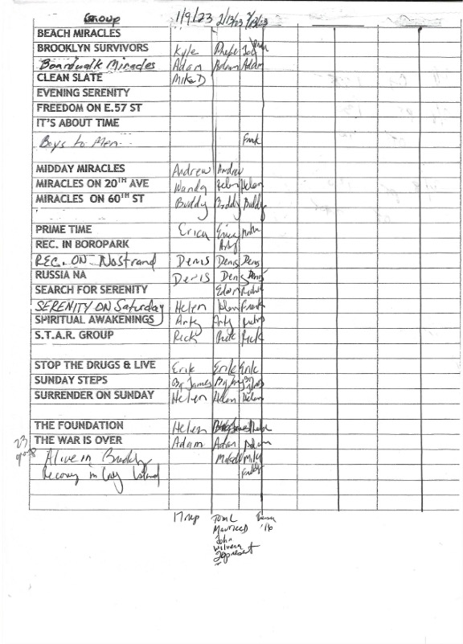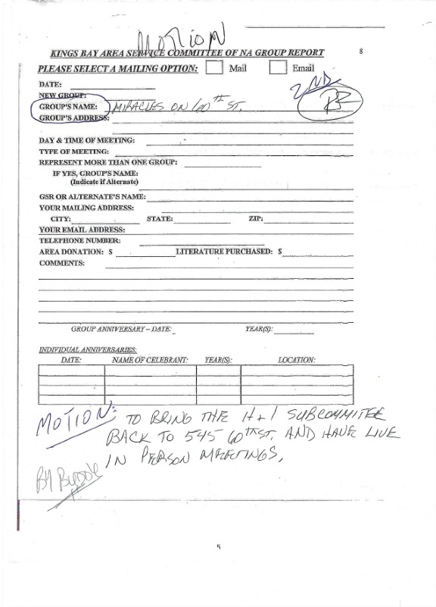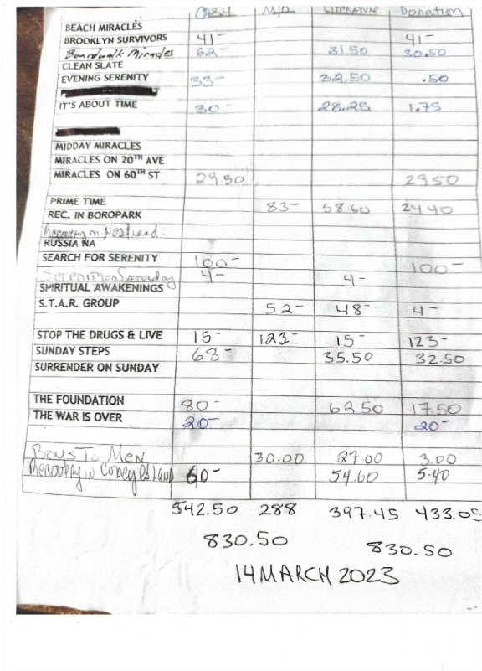
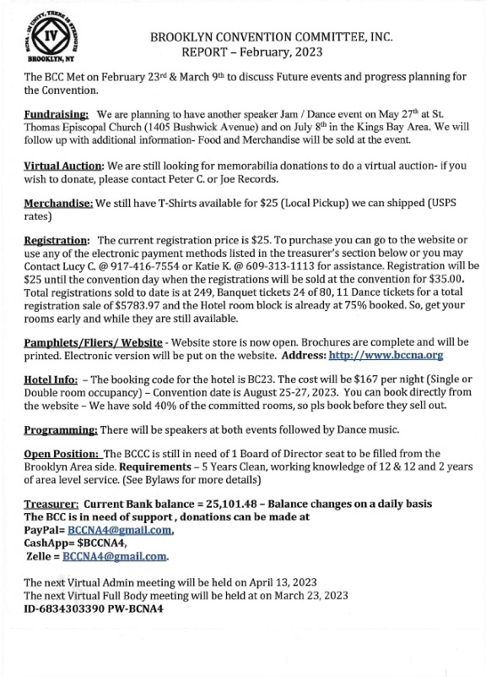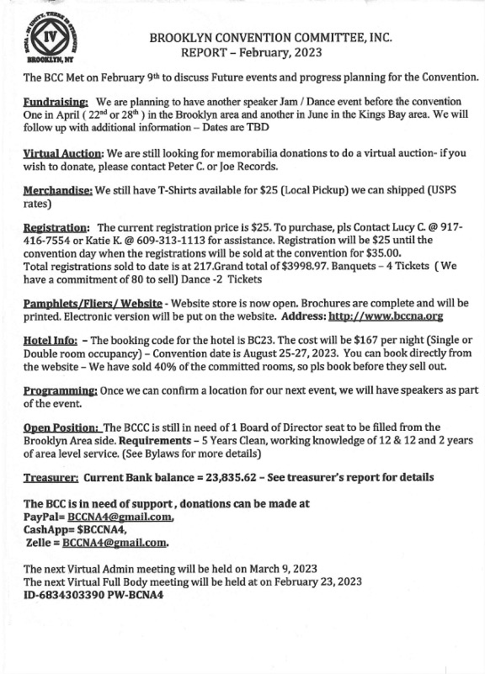
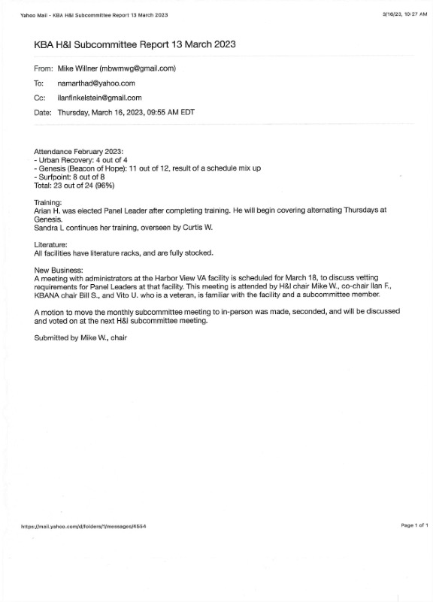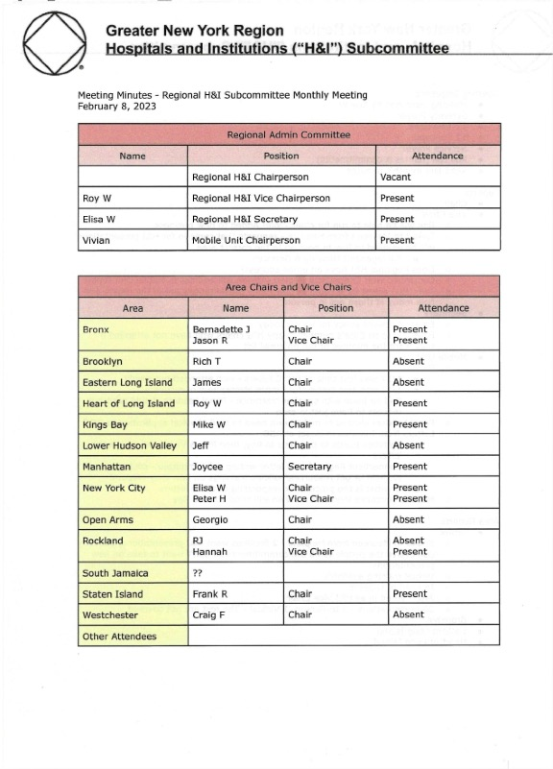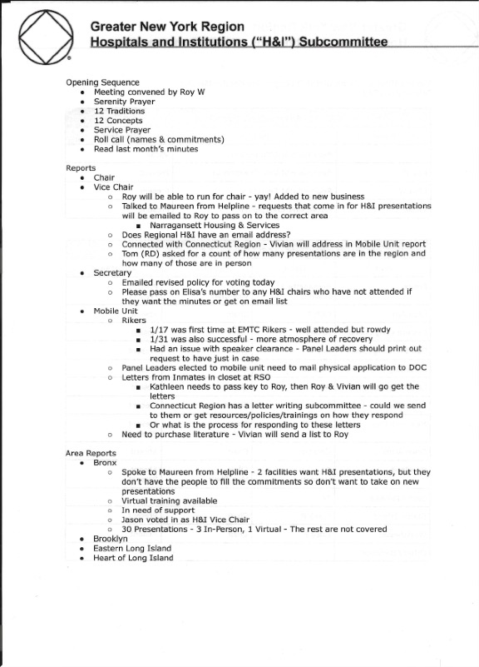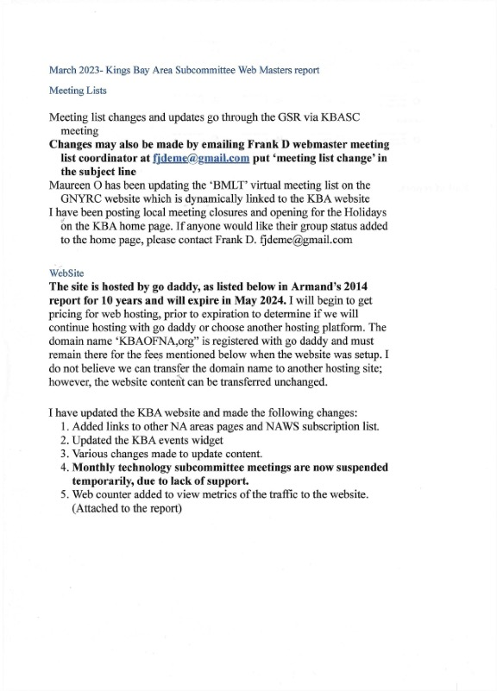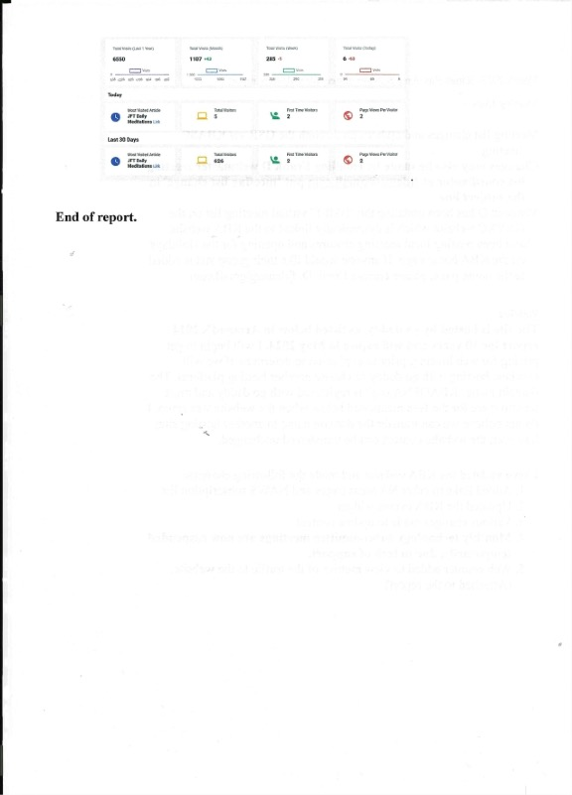
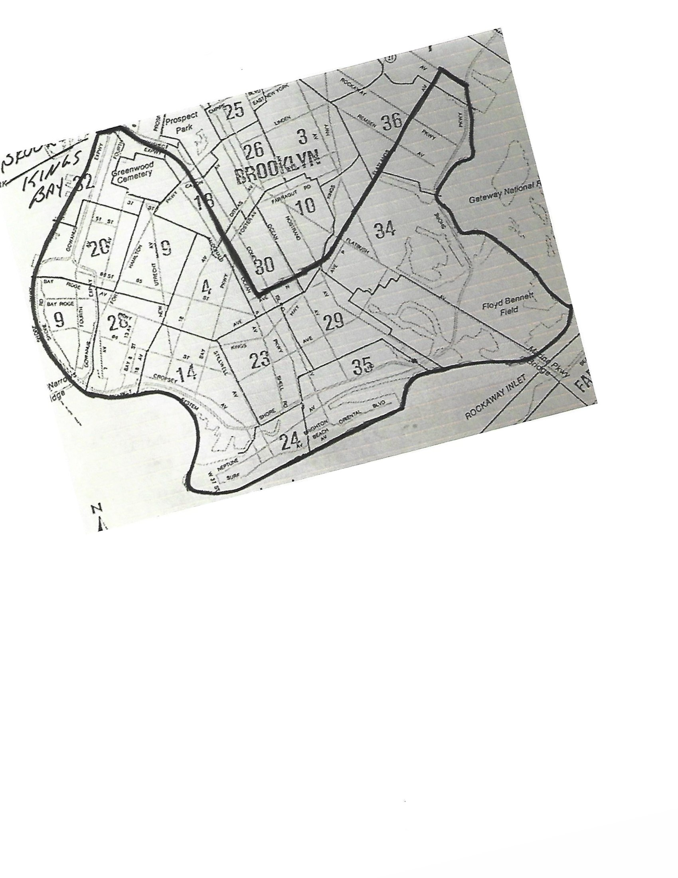
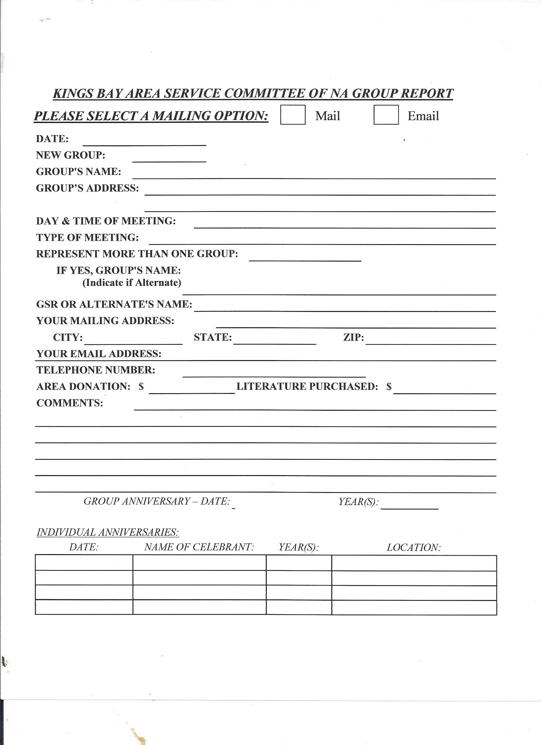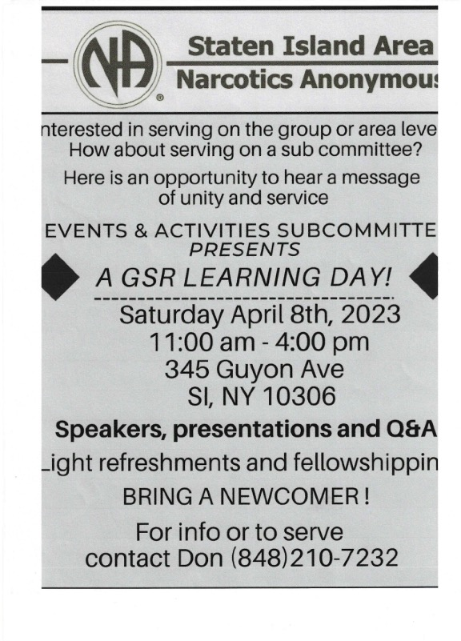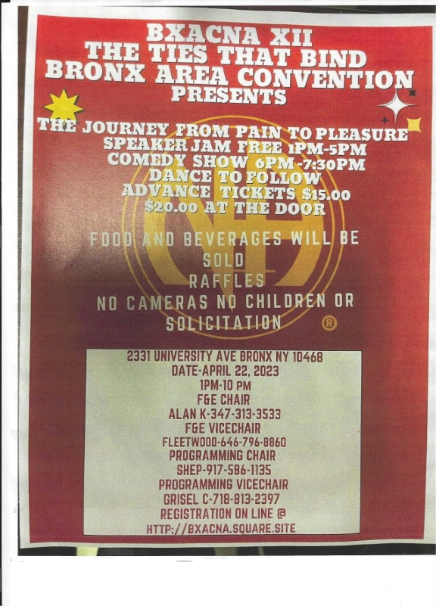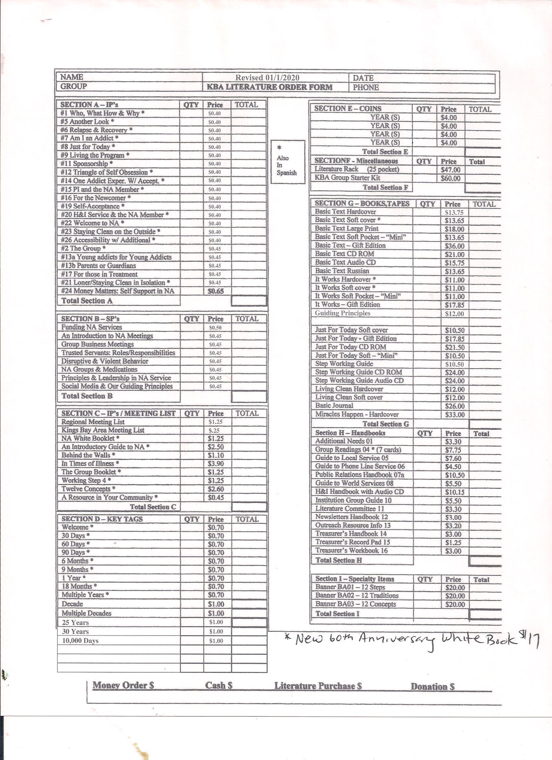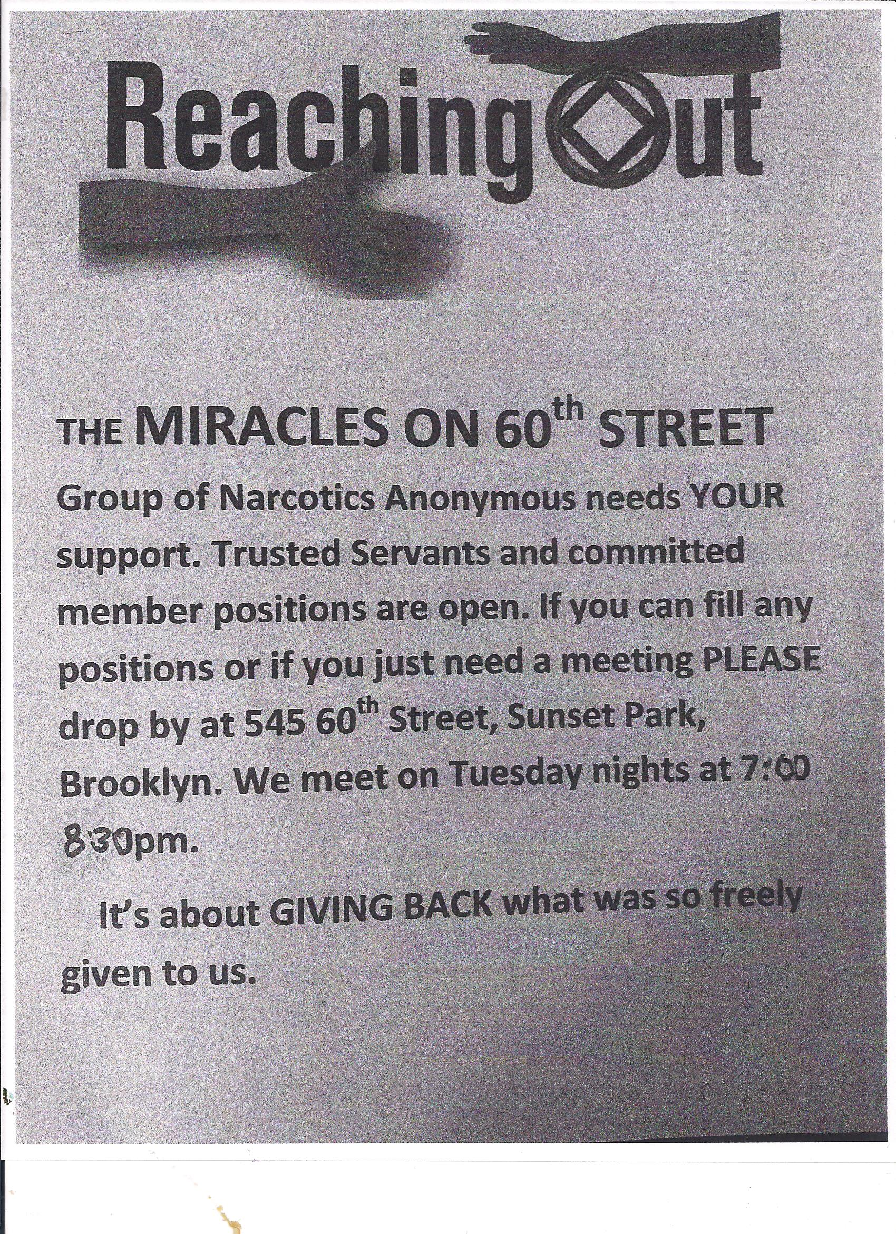
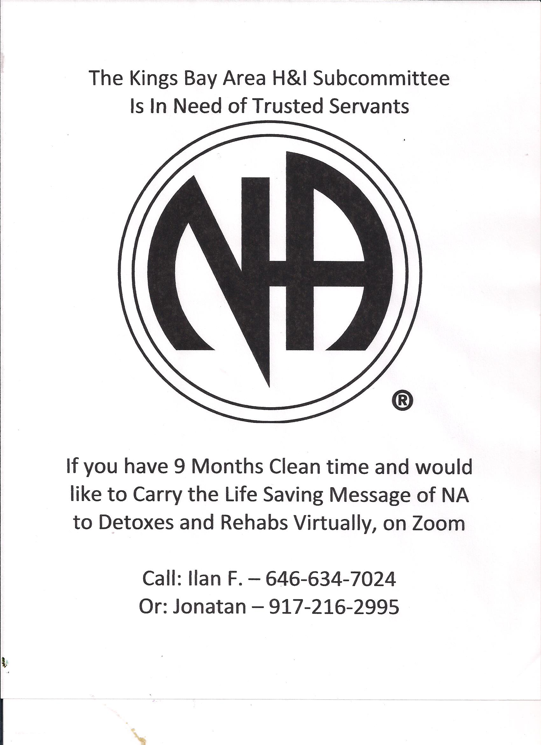
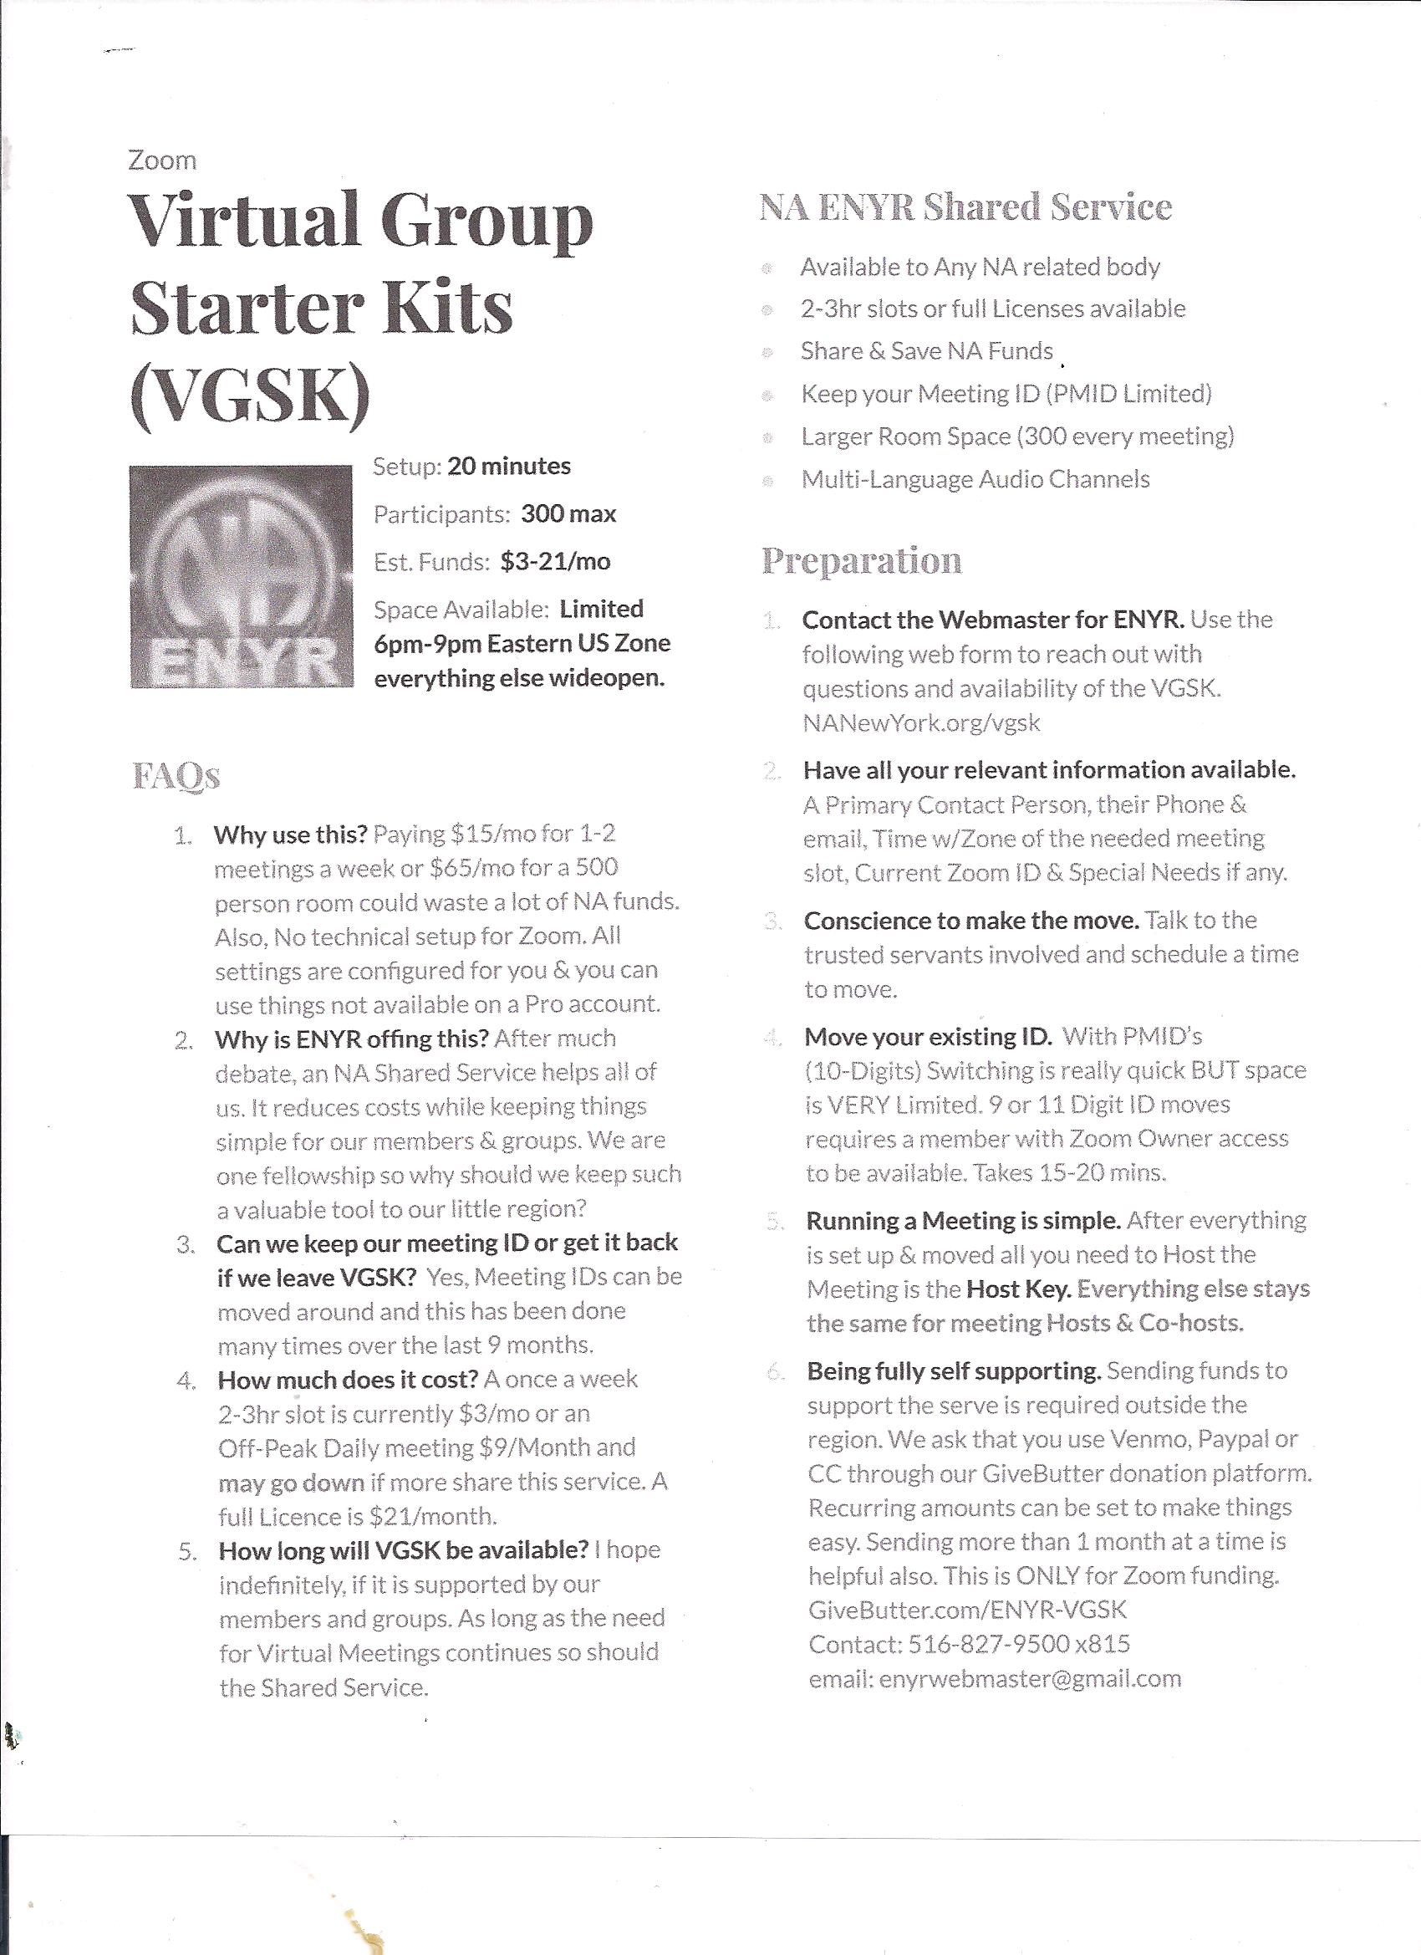MIDDAY MIRACLE KBA Online Meetings DAILY
Weekdays (M-F) at 10am
Zoom ID: 665 503 2384
Password: 173349
ALIVE IN BROOKLYN GREATER NEW YORK CITY REGIONAL MEETINGS
Every Day at 7:30pm http://bit.ly/na-meeting-guide
Zoom ID: 697 663 4645
Password: 1
https://docs.google.com/document/d/1KIvDT9pDauBooQTPaApV1hngYkzz15Wts2ablfRbB8/edit
RECOVERY IN CONEY ISLAND
Every Day at 7pm
Zoom ID:813 0904 2099
Password: 123456
MONDAYTHE WAR IS OVER
Mondays at 8pm
Zoom ID: 374 301 074
Password: 368296
WEDNESDAYSOLO POR HOY
Spanish Speaking
Wednesdays at 7pm
Zoom ID: 610 132 2211
Password: 553764
FRIDAY STEPS TO FREEDOM
Fridays at 9:00PM
Zoom ID: 824 915 1032
Password:
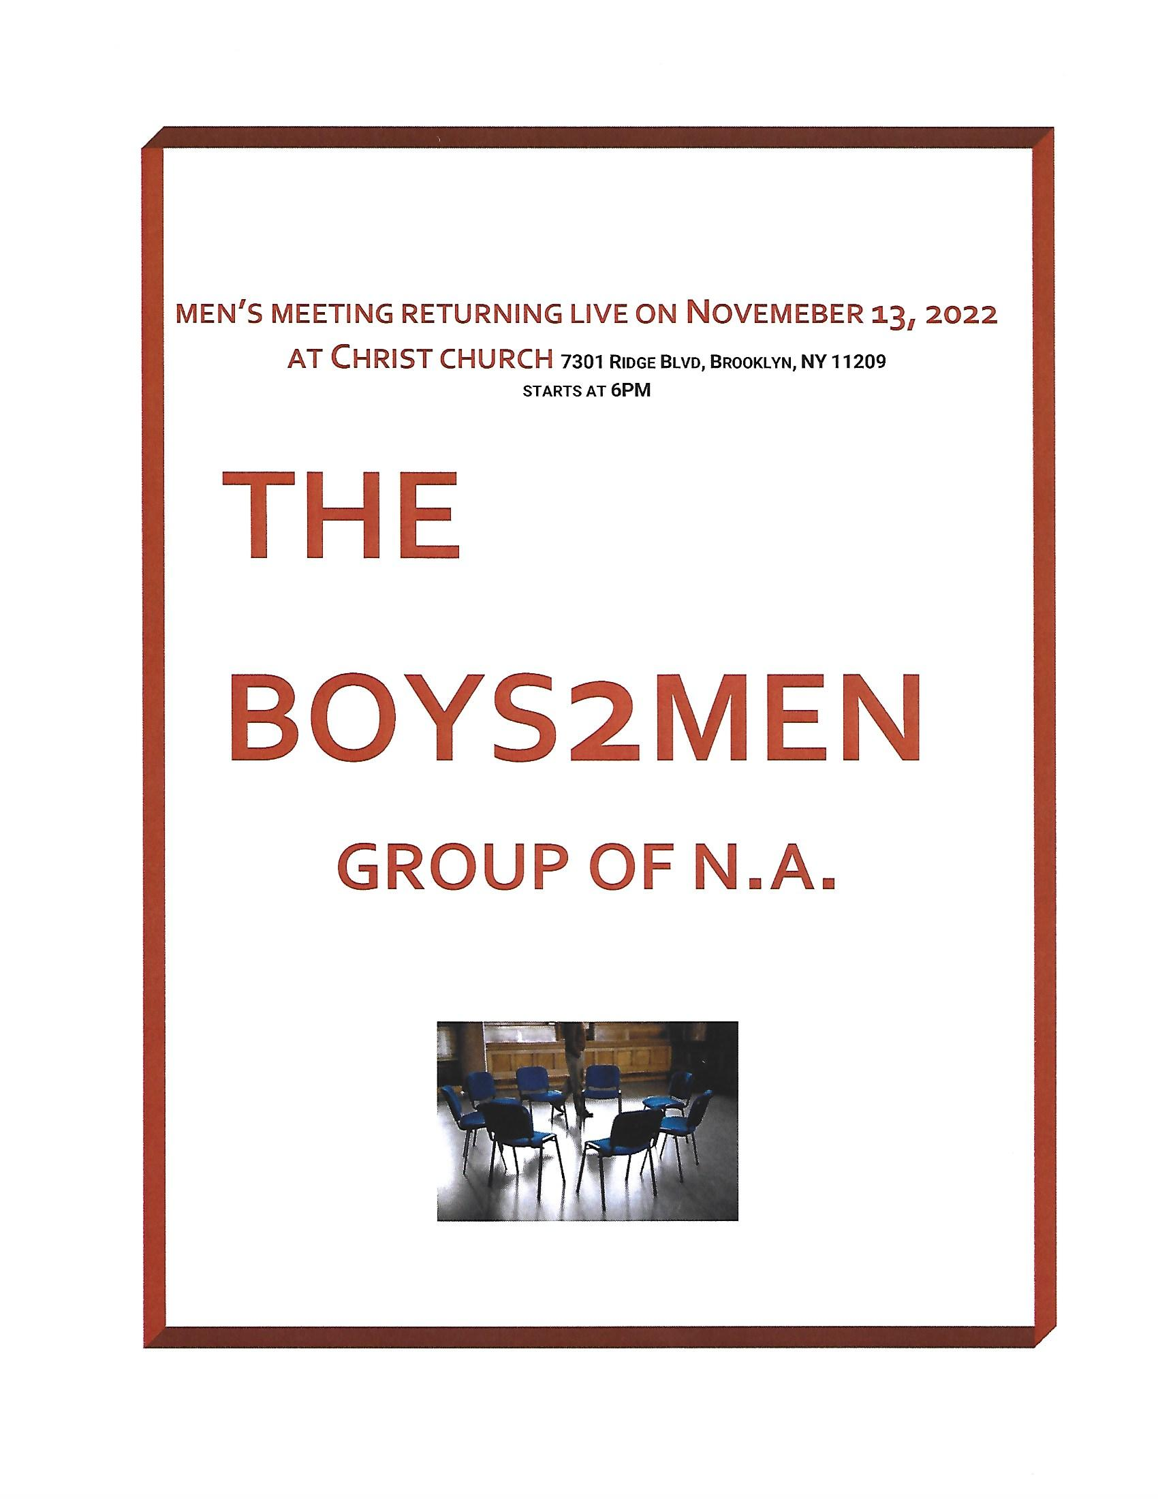
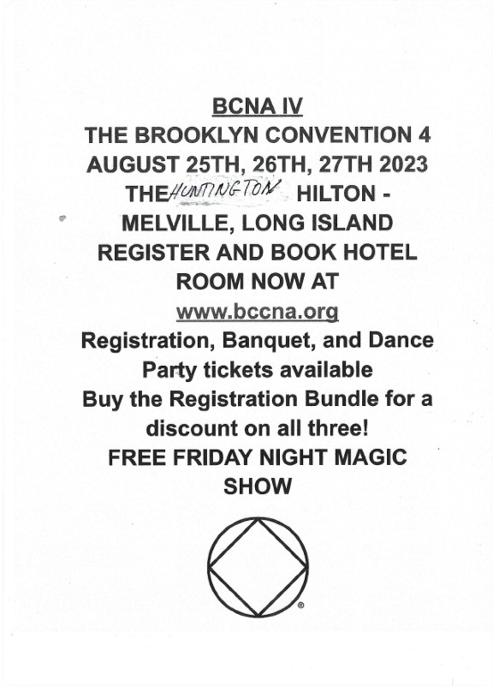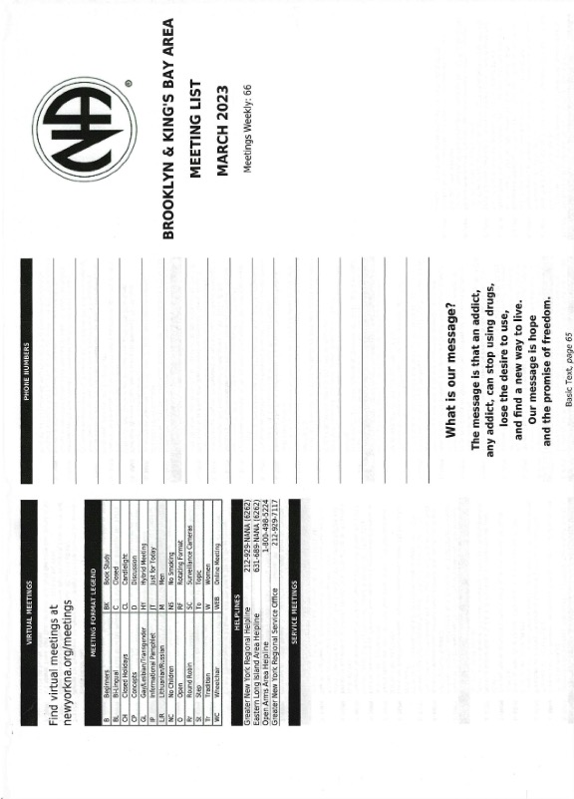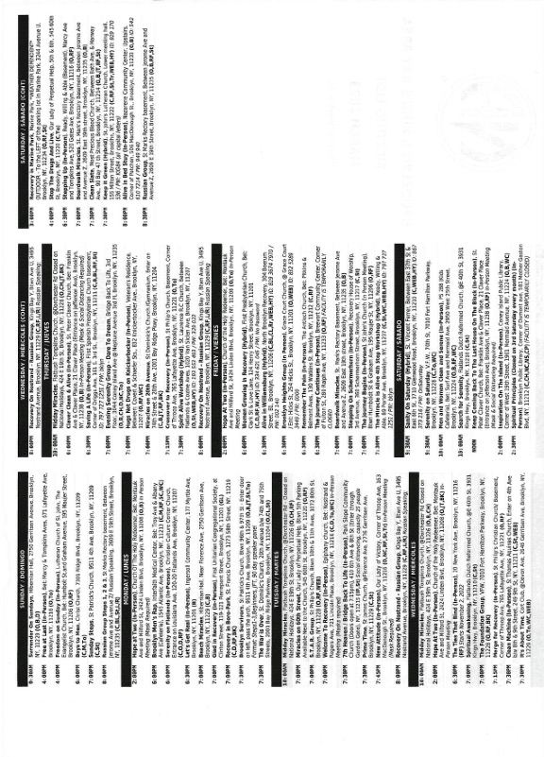
MAR 25 | LONNIE | 33 YEARS | STOP THE DRUGS AND LIVE
MAR 25 | RICHIE RICH  NICOLE F | 33 YEARS  7 YEARS | CLEAN SLATE
MAR 26 | STEVE R  JACK R | 32 YEARS  23 YEARS | SUNDAY STEPS
MAR 27 | GABRIELLA G | 28 YEARS | THE WAR IS OVER
MAR 29 | DEBBIE M | 43 YEARS | SPIRITUAL AWAKENING
APR 4 | VLADIMIR | 6 YEARS | RUSSIAN GROUP
APR 11 | VICKY G | 12 YEARS | PRIME TIME
APR 12 | JOE W | 8 YEARS | IT’S ABOUT TIME
APR 18 | ENRIQUE | 1ST YEAR | RECOVERY IN CONEY ISLAND
APR 19 | WALTER BEAR | 6 YEARS | THE FOUNDATION
APR 19 | CHANITA | 2 YEARS | SPIRITUAL AWAKENING
APR 20 | LENORE | 24 YEARS | MIRACLES ON 20TH AVE
APR 24 | PETER G | 37 YEARS | BEACH MIRACLES
APR 24 | EUGENE | 3 YEARS | BROOKLYN SURVIVORS
APR 25 | LINDA C | 1ST YEAR | PRIME TIME
APR 25 | SAL M | 1ST YEAR | STAR GROUP
APR 29 | FRANK D | 6 YEARS | SERENITY ON SATURDAY
APR 29 | BUDDY FROM BROOKLYN  RALPHIE O | 34 YEARS  10 YEARS | STOP THE DRUGS AND LIVE
APR 29 | ANGEL S | 8 YEARS | CLEAN SLATE
APR 30 | ERICA  MARIANNA P | 28 YEARS  1ST YEAR | SURRENDER ON SUNDAY
MAY 19 | SALLY PUMPS | 2 YEARS | BOARDWALK MIRACLES
MAY 24 | MAYER | 12 YEARS | THE FOUNDATION
MAY 25 | JOE G | 37 YEARS | MIRACLES ON 20TH AVE
MAY 30 | ANNE G  DONNA | 11 YEARS  11 YEARS | STAR GROUP
KINGS BAY AREA ANNIVERSARY LIST

