**KINGSBAY AREA SERVICE COMMITTEE**

**2059 West 11th Street, Brooklyn NY 11223 *KBAofNA.org***

**Monthly Report**

**Meeting Date: July 10, 2023 6:30 PM**

**Meeting opened @ 6:30 PM** - Serenity Prayer, 12 Traditions, 12 Concepts and Service Prayer were read.

**ROLL CALL:** Trusted servant’s & Group’s roll call taken (included).

**REPORTS:**

**CHAIRPERSON:** We are taking ADVANCED orders for our KBA T-shirts. To ensure you get the needed sizes and colors you prefer contact Adam or Martha. They we will be men’s and women’s high quality Gildon Vee Necks $15.00 a piece, We now have our **steering committee meetings the last** **Monday** of every month at 6:00pm via zoom, ID# 6101322211 password 553764. Our next one is July 31, 2023.Our annual picnic is scheduled for September 16, from 10-4 in Manhattan Beach (flyer attached).

**VICE-CHAIRPERSON:** Open position.

**Treasurer**: (Report attached) Our current balance is $5,457.72. We now have SPECIALTY key tags in 5, 10, 15, 20, 25, and 30 years at $2.50 each. We also have 10,000 days and Welcome Back key tags. We have the LIMITED Edition 60TH year White Book for $15 each. We also have SPAD Spiritual Principle a Day we are selling for $15 each. NAWS has raised our prices so we had to raise ours also so please use the **NEW LITERATURE ORDER FORMS** (attached). Capital One is closing our account for no apparent reason so we are looking for another bank to transfer our funds.

**Public Information:** Open Position.

**H & I**: (report attached) We had elections Vice-Chair Buddy from Brooklyn, Literature Chair Andrew R, Secretary Gemma, Panel Coordinator for Urban Recovery Rudy.We are currently in Genesis, Urban Recovery and Surfpoint. A fire at Urban Recovery caused us to move meetings outside. The VA is open on Tuesday nights. We need trusted servants to help carry the message (see attached flyer). The Vice Chair position is open for elections. Our subcommittee meets the third Monday of every month from 6-7pm at 545 60th Street.

**RCM/RCM ALT:** Open Position. The GNYRSO meets the second Saturday of every odd month via Zoom at 10 am. The Region is currently looking for additional Board of Directors to take the place of the ones that rotated out the clean time requirement is 5 years. The next regional convention is now scheduled for Labor Day weekend 2025 at the Hilton in Manhattan. The GNYRSO is open sporadically so go online to check their hours. Please post all events to go on the regional calendar at calendar@newyork.org. please email flyers/other event info to rso@newyork.org.

**E & A**: Our annual picnic is planned for Saturday, September 16, 2023 from 10am to 4pm in Manhattan Beach, Falmouth Street and Oriental Blvd. (flyer attached). We will have T-shirts for sale. We are counting on your support. Our next subcommittee meeting is on **Saturday August 12 at 6:30 at Clean Slate, 90 Bay 47 Street.** We hope to have a Halloween event on 10/28 at St. Patricks.

**Brooklyn Convention:** (report and convention registration attached) ***Our NEW CONVENTION DATE is August 25-27, 2023****.* Our website is up and running, [www.BCCNA.com.](http://www.bccna.com/) Our balance is 27,819.84(balance sheet attached). If anyone wants to mail donations, etc. please use this address; Brooklyn Convention Committee, P.O. Box 604641, Bayside, NY 11360.. Preregistration is $25 until 7/31 then it’s $35.Hotel rooms are 80%out. Banquet tickets are $60.

**Meeting List/Webmaster:** (report attached) Go to ***KBAofNA.org.*** Our contract with Go Daddy will end in March 2024. The domain name if we are to keep it must stay with Go Daddy but we can go with a different hosting site. So far the cheapest is $500 for 5 years. I am currently pricing additional hosts to see which is more cost effective for us. There is now information on the website about how you mail your donations to our address. There are additional links, updates, and widgets.

**Policy:** OPEN POSITION

**Group Concerns:**

Surrender on Saturday needs support.

Miracles on 20th Ave needs trusted servants.

The BOYS2MEN group has now reopened, 7301 Ridge Blvd. and needs support.

The Kings Bay Area Brooklyn Convention Committee needs support.

Prime Time needs a co-chair.

Spiritual Awakening and Search for Serenity lost their chairperson and is in dire need of another or they will shut down.

**New Business:**

New charcoal grill has been purchased for $325.54

**The next KBASC will be held on:**

Monday, August 14, 2023, at 6:30pm at OLPH 545 60thSt.

|  |  |  |  |  |
| --- | --- | --- | --- | --- |
| Position | Trusted Servant | Phone # | Email Address | Attendance |
| Chair | **Bill S.** | 917-709-7464 | [Billysal52@gmail.com](mailto:Billysal52@gmail.com) |  |
| Vice Chair | OPEN |  |  |  |
| Secretary | Martha D. | 917-476-4403 | [NAMarthaD@Yahoo.com](mailto:NAMarthaD@Yahoo.com) | Present |
| Treasurer | Adam D. | 917-681-4520 | [Lionspaw3000@gmail.com](mailto:Lionspaw3000@gmail.com) | **Present** |
| Literature | **Andrew R.** | 347-633-0912 | [Andrewreda628@gmail.com](mailto:Andrewreda628@gmail.com) | **Present** |
| Meeting List/ WebMaster | Frank D. | 347-631-4540 | [fjdeme@gmail.com](mailto:fjdeme@gmail.com) |  |
| Newsletter | OPEN |  |  |  |
| H & I | Mike W. | 917-817-1814 | [mbwmwg@gmail.com](mailto:mbwmwg@gmail.com) | Present |
| H&I vice-chair | Buddy from Brooklyn | 917-562-6909 | [Thewanderer4809@hotmail.com](mailto:Thewanderer4809@hotmail.com) | **Present** |
| E & A | Mike D. | 718-600-3652 | [Mike115@gmail.com](mailto:Mike115@gmail.com) | Present |
| E & A vice -chair | OPEN |  |  |  |
| Policy | OPEN |  |  |  |
| RCM-Acting | Martha | 917-476-4403 | [Namarthad@yahoo.com](mailto:Namarthad@yahoo.com) | Present |
| RCM-alt | Adam D. | 917-681-4520 | [Lionspaw3000@gmail.com](mailto:Lionspaw3000@gmail.com) | **Present** |
| Literature Review | OPEN |  |  |  |
| Merchandise | OPEN |  |  |  |
| Public Relations | OPEN |  |  |  |
| Brooklyn Liaison | **OPEN** |  |  |  |
| Conv. Chair **Conv. Treas.** | **Joe Records**  **Richie Rich** | **917-209-2499**  **917-734-0876** | [**Joeyvinyl@gmail.com**](mailto:Joeyvinyl@gmail.com)  [**Richardmannarinoaol.com**](mailto:Richardmannarino@aol.com) |  |
| Homebound | **OPEN** |  |  |  |
| Speaker Exchange | **OPEN** |  |  |  |

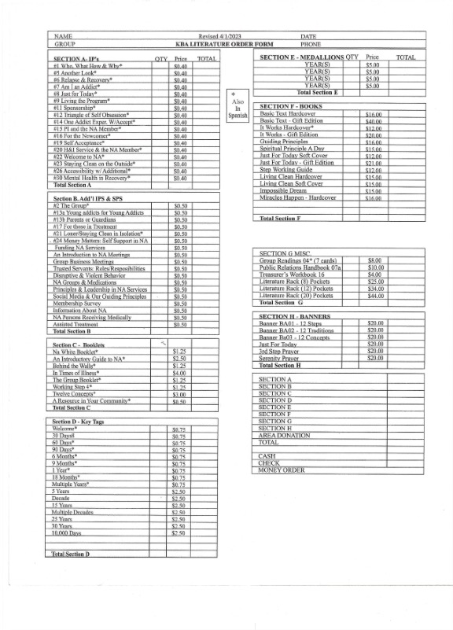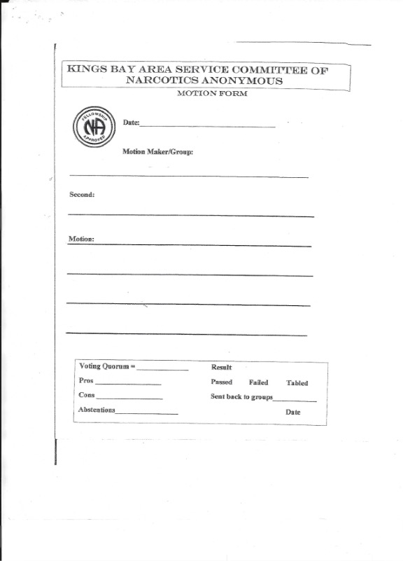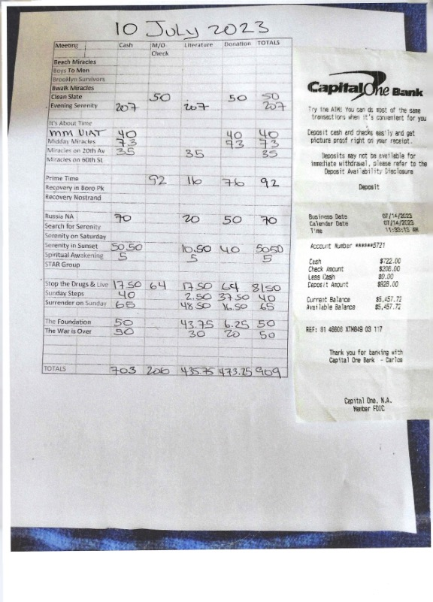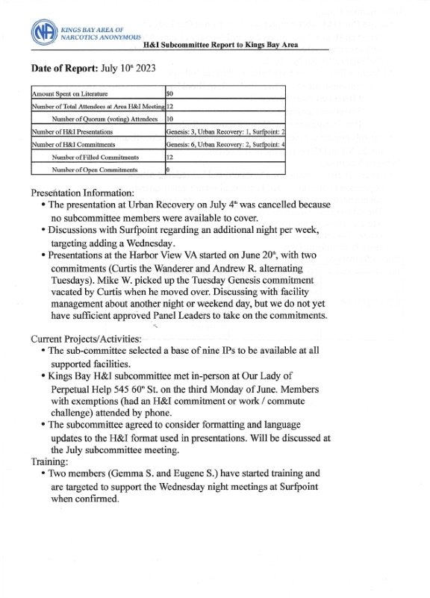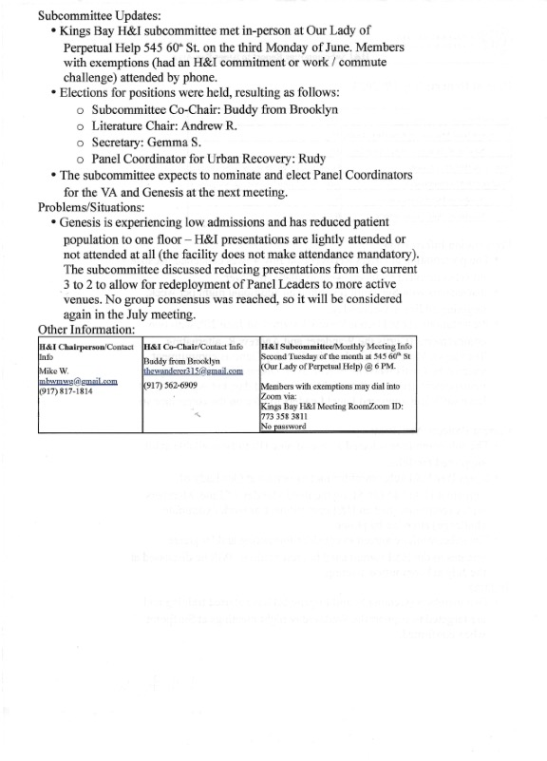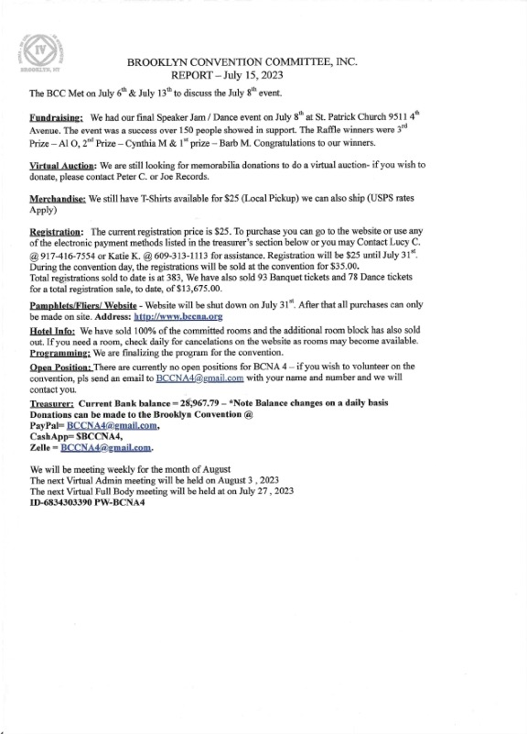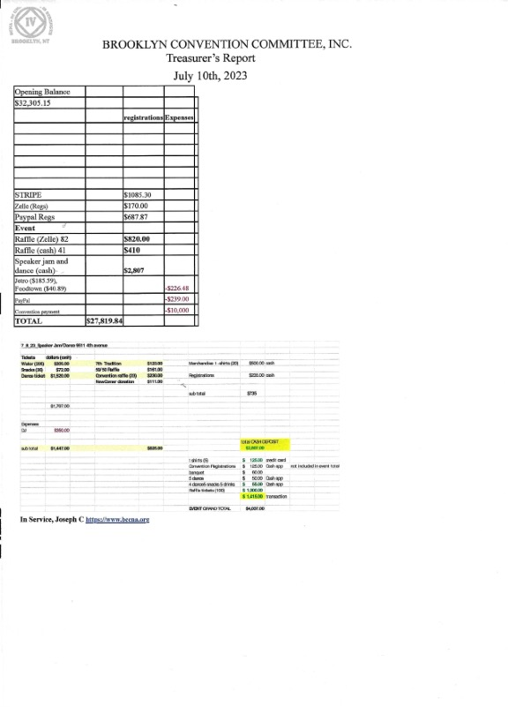

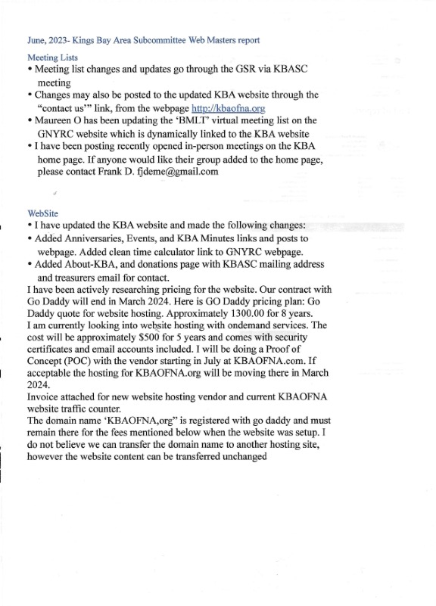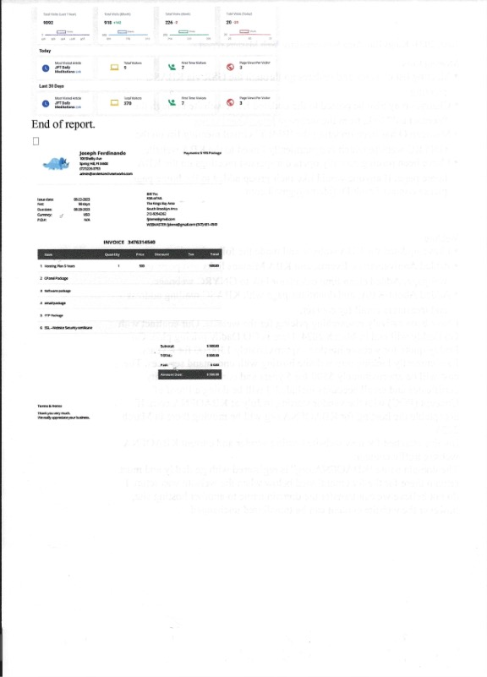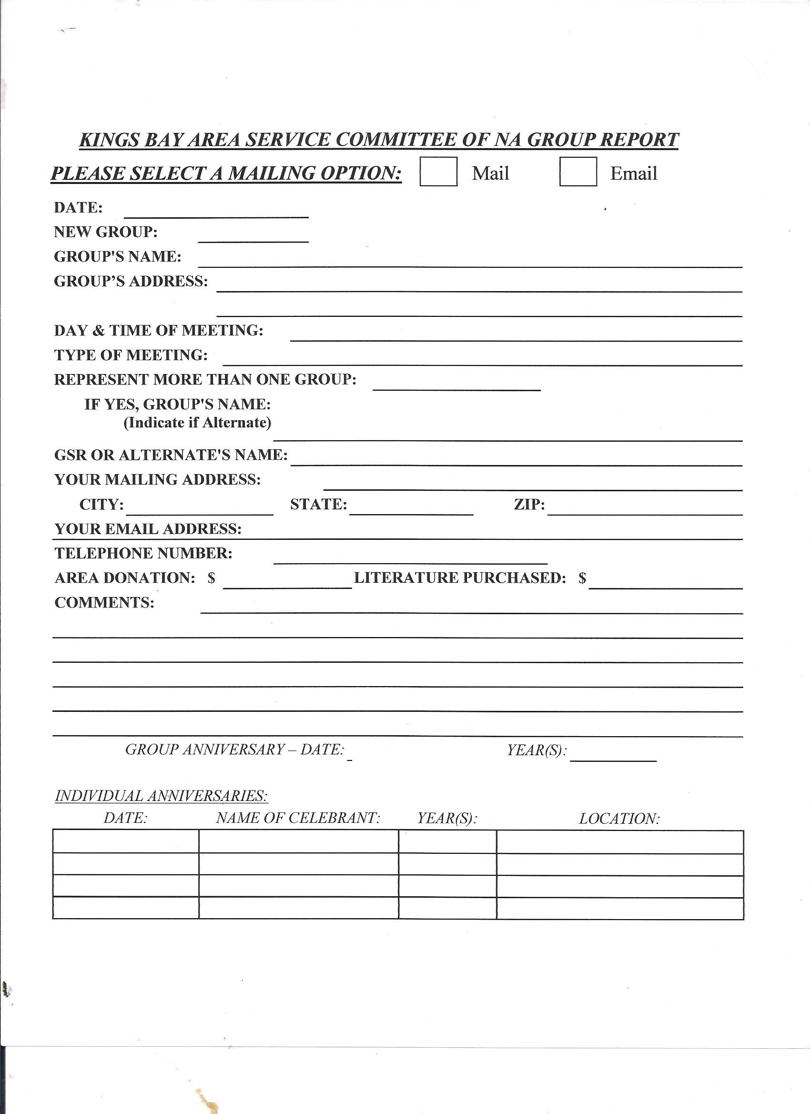 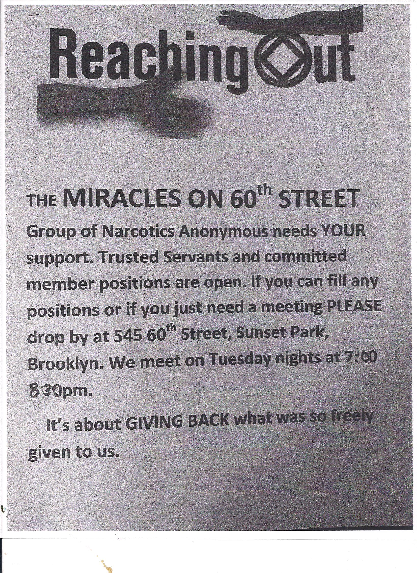

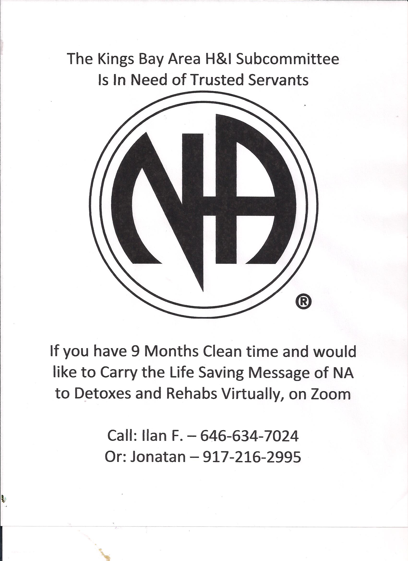

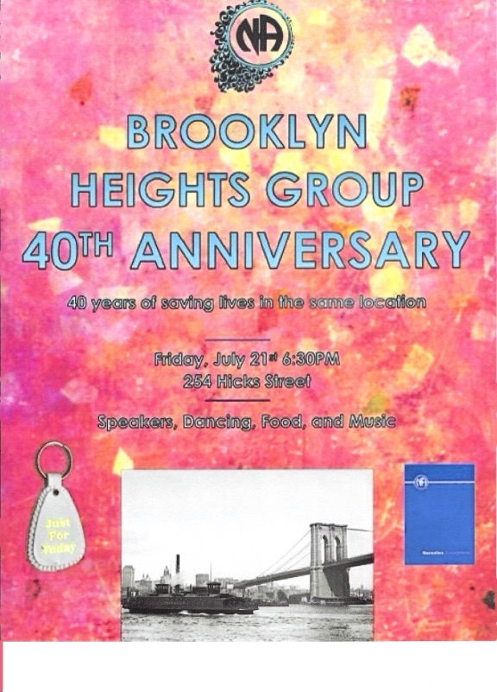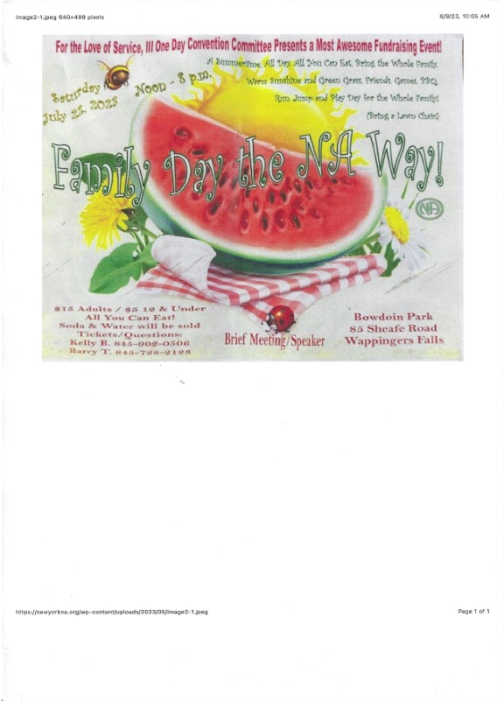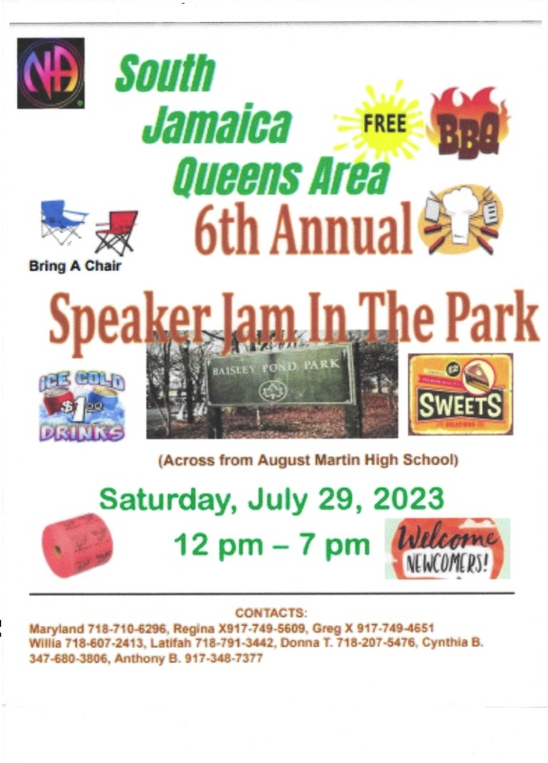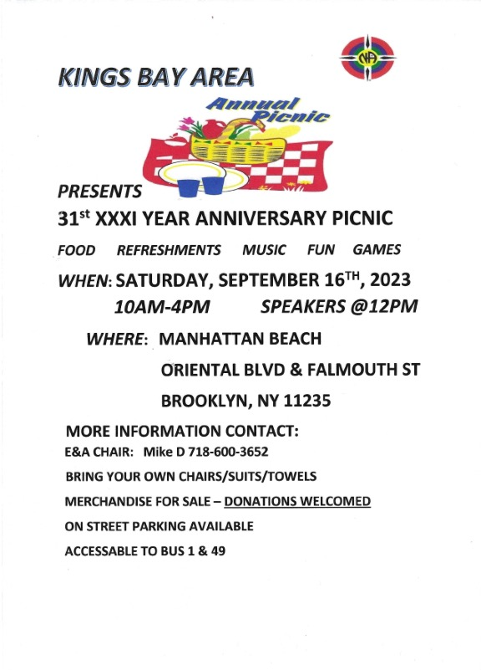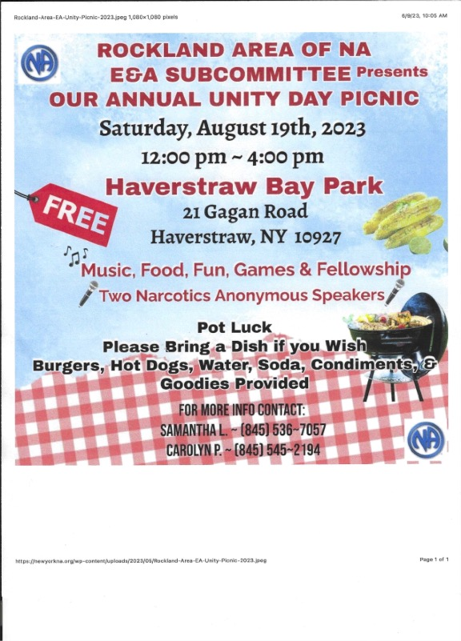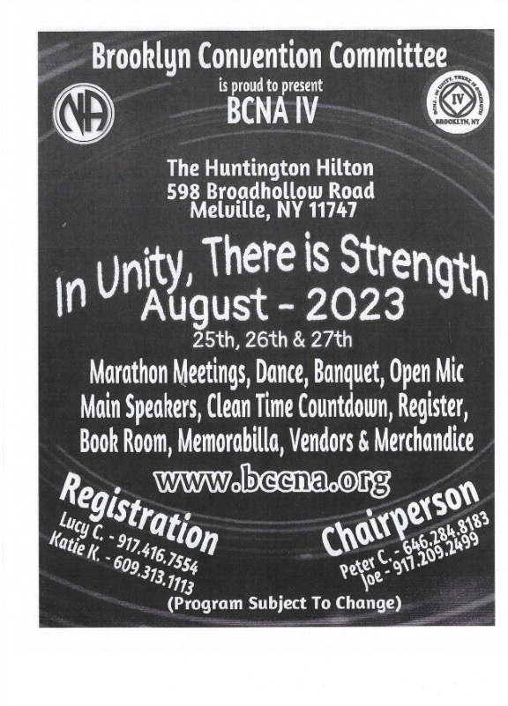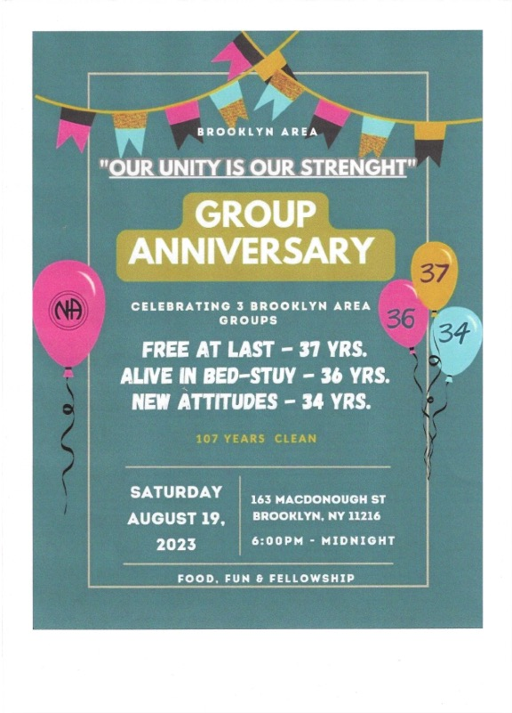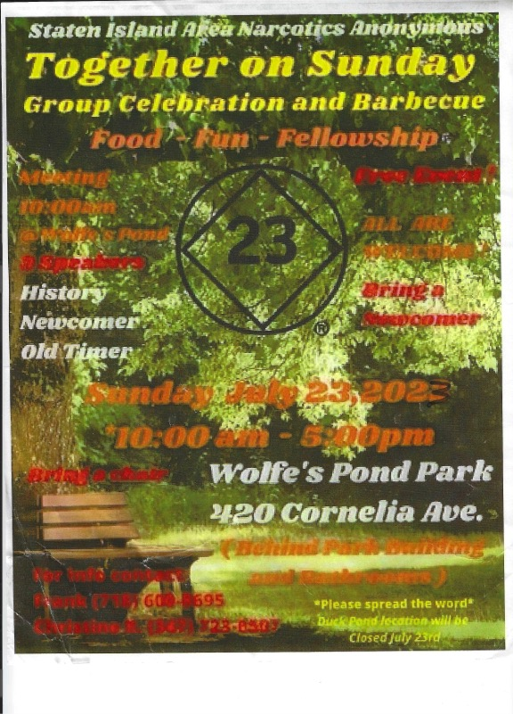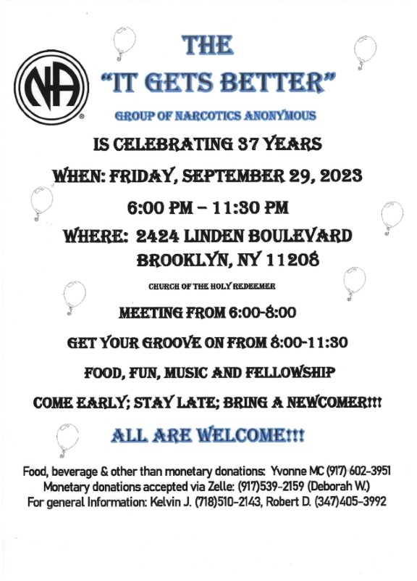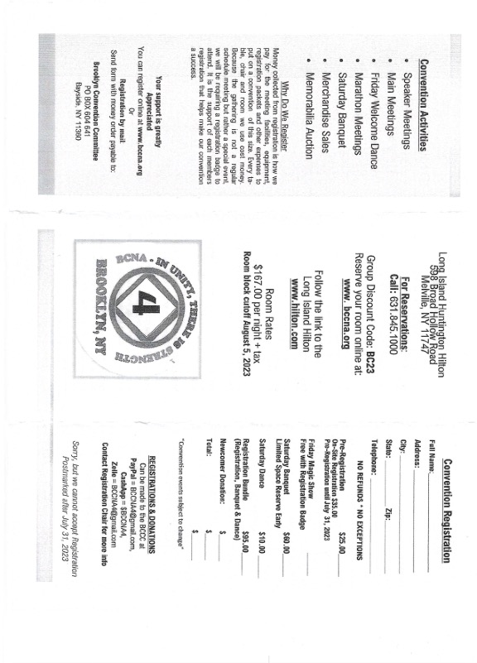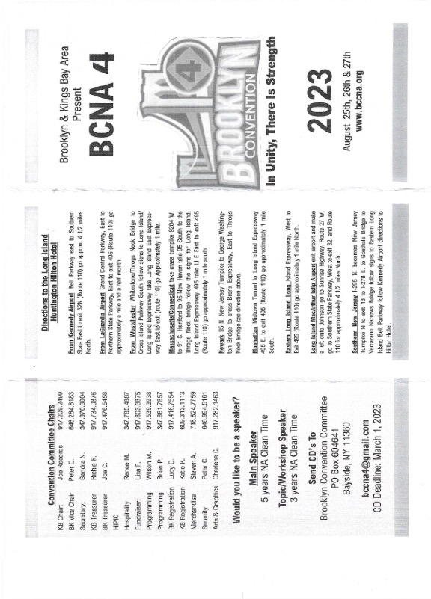

*MIDDAY MIRACLE* **KBA Online Meetings DAILY**

Weekdays (M-F) at 10am

Zoom ID: 665 503 2384

Password: 173349

*ALIVE IN BROOKLYN* **GREATER NEW YORK CITY REGIONAL MEETINGS**

Every Day at 7:30pm <http://bit.ly/na-meeting-guide>

Zoom ID: 697 663 4645

Password: 1

<https://docs.google.com/document/d/1KIvDT9pDauBooQTPaApV1hngYkzz15Wts2ablfRbB8/edit>

*RECOVERY IN CONEY ISLAND*

Every Day at 7pm

Zoom ID:813 0904 2099

Password: 123456

**MONDAY***THE WAR IS OVER*

Mondays at 8pm

Zoom ID: 374 301 074

Password: 368296

**WEDNESDAY***SOLO POR HOY*

Spanish Speaking

Wednesdays at 7pm

Zoom ID: 610 132 2211

Password: 553764

**FRIDAY** *STEPS TO FREEDOM*

Fridays at 9:00PM

Zoom ID: 824 915 1032

Password:

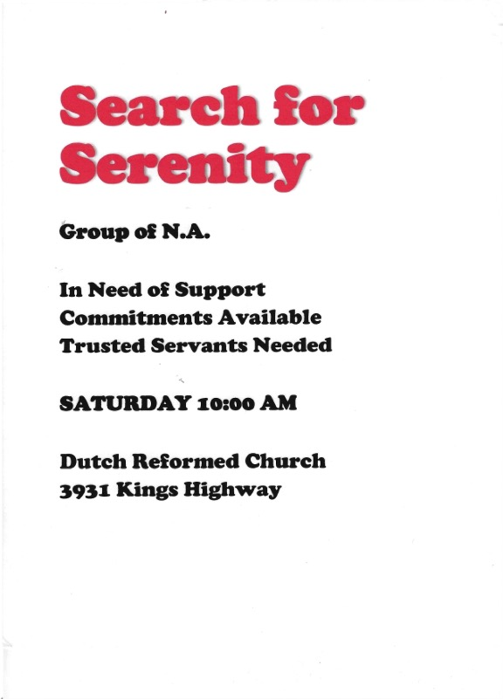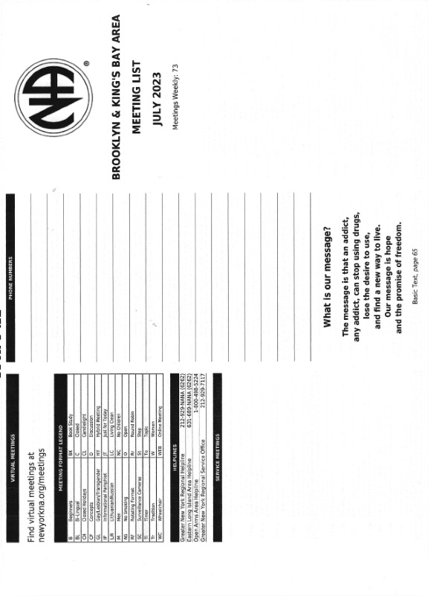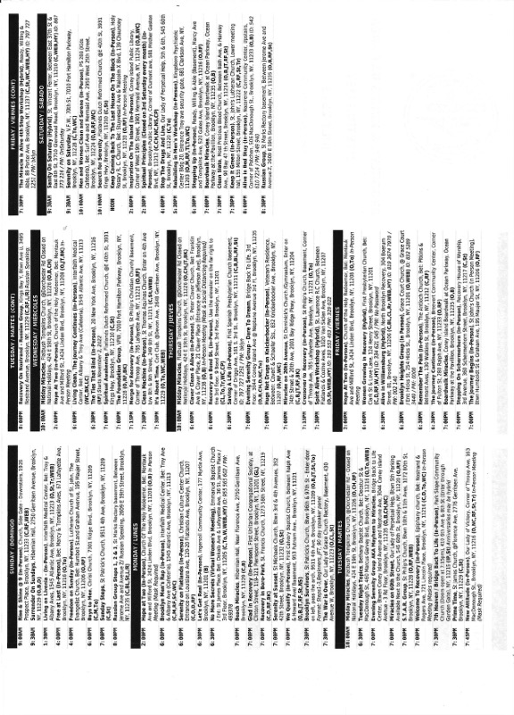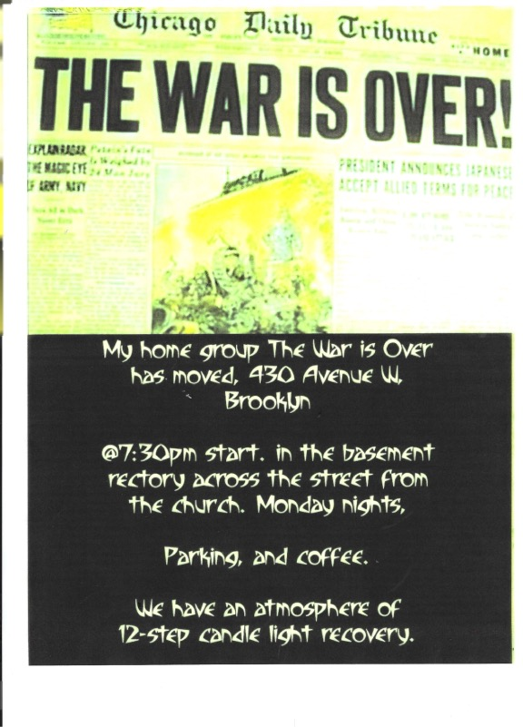

|  |  |  |  |
| --- | --- | --- | --- |
| **JULY 19** | **JOHN R** | **31 YEARS** | **SPIRITUAL AWAKENING** |
| **JULY 25** | **JOHNNY TIMES** | **29 YEARS** | **STAR GROUP** |
| **JULY 25** | **COUSIN VINNY** | **3 YEARS** | **PRIME TIME** |
| **JULY 25** | **CARLOS V** | **33 YEARS** | **ALIVE IN BROOKLYN** |
| **JULY 29** | **UMBE** | **8 YEARS** | **STOP THE DRUGS AND LIVE** |
| **JULY 29** | **BEK** | **6 YEARS** | **THE RUSSIAN GROUP** |
| **JULY 30** | **BIG JAMES** | **30 YEARS** | **SUNDAY STEPS** |
| **JULY 31** | **FERNANDO G**  **JR O** | **21 YEARS**  **21 YEARS** | **SERENITY IN SUNSET** |
| **JULY 31** | **CURTIS** | **12 YEARS** | **HOPE N THE SLOPE** |
| **AUG 2** | **AL B**  **PRESTON** | **20 YEARS**  **7 YEARS** | **IT’S ABOUT TIME** |
| **AUG 5** | **DENIS** | **19 YEARS** | **THERUSSIAN GROUP** |
| **AUG 15** | **LITTLE DONNA** | **40 YEARS** | **PRIME TIME** |
| **AUG 19** | **MARIA C** | **35 YEARS** | **CLEAN SLATE** |
| **AUG 21** | **RIBEYE ROB** | **1ST YEAR** | **THE WAR IS OVER** |
| **SEPT 18** | **CAROLANN** | **1ST YEAR** | **GLAD IN RECOVERY** |
| **SEPT 30** | **WALTER D** | **43 YEARS** | **SUNDAY STEPS** |
|  |  |  |  |
|  |  |  |  |
|  |  |  |  |
|  |  |  |  |
|  |  |  |  |
|  |  |  |  |

**KINGS BAY AREA ANNIVERSARY LIST**